

**It’s time to talk about money**

Speech given by

Sir Jon Cunliffe, Deputy Governor Financial Stability, Member of the Monetary Policy Committee, Member of the Financial Policy Committee and Member of the Prudential Regulation Committee

London School of Economics, London 28 February 2020

I am grateful to Alex Michie for his assistance in drafting these remarks and Ben Dyson, John Jackson, Josh Sadler, Tom Mutton, Alice Carr, Emma Sinclair, Ryland Thomas,

Michaela Costello, Chris Ford, Simon Scorer, Justin Jacobs, Wayne Chapman, Samantha Riley

and the Bank’s Archivists for their input.

## Intro

One of the questions that I find hardest to answer simply is “what does the Bank of England do?”

I get asked this penetrating question a lot, especially by children when I visit schools as part of the Bank’s outreach and education programme – which incidentally is one of the most rewarding parts of my job.

There is a long, comprehensive and accurate answer of course, describing our monetary policy and financial stability objectives, policies and actions and our role in demand management. When I talk to economics classes in schools, I can often feel their teachers willing me to come out with these textbook answers.

But I find that the better and simpler answer is that we are responsible for ensuring that the money of the United Kingdom ‘works’. Money, like electricity and water, is crucial to the operation of a modern society. Our job is to ensure it works safely and reliably, through ups and downs, so that everyone in society can depend upon it.

That means ensuring its value can be depended upon – monetary stability. It means ensuring that the banking system, which creates and issues most of the money we actually use, as well as the payment systems through which that money moves, are safe and can be relied upon – financial stability. It means ensuring that the physical money the Bank of England actually produces – the cash we use – cannot be forged and can be used with confidence.

Money, of course, can be a slippery concept. It is, I think, best described as a social convention, the way we calibrate, exchange, store and settle claims we hold on each other in the economy. That convention has been expressed in very different ways at different times and in different societies. It can be expressed in different ways at the same time.

At the moment in the United Kingdom, all money is denominated in one unit of account, the pound sterling1, but it takes different forms.

It can be expressed physically as actual claims on the state, in the form of the Bank of England: the banknotes we issue with the famous promise to ‘pay the bearer’. A very small proportion takes the form of physical tokens issued by the state that do not contain any claim – the coins issued by the crown. And 97% of the money we use, for transacting and storing our wealth, takes the form of electronic claims on banks – what we call ‘commercial bank money’.

We use these different forms interchangeably and without really knowing – or needing to know – what is behind them and why they are reliable expressions of the social convention that is money – why they can be

1 The meaning of pound sterling has evolved over time but is thought to date back 1,200 years and referred to physical weight of silver coinage.

transferred, will be accepted and will hold their value through time. It is our job, at the Bank, to ensure those things.

But the forms money takes in society is not fixed. Those forms change as the structure of economies changes, as the ways in which we transact with each other change, as technology makes new forms possible.

We think of medieval England as a society using state issued metallic tokens – coins stamped with the monarch’s head – as its main form of money. But transferable debt obligations, recorded on notched sticks of wood, the ‘tally sticks’, also functioned as money, not for day-to-day use, but for large transactions.2

We think likewise of the gold standard period, following Sir Isaac Newton’s coinage reforms, as one in which metallic money dominated. But again, although coins were the everyday means of exchange, transferable private sector claims, in the forms of banknotes and ‘bills of exchange’, were still significant in trade and commerce.

This is not just ancient history. We have seen a big change in my lifetime. When I was at school, admittedly a very long time ago, physical cash – banknotes and coins – played a far larger role in our lives. Far fewer people had bank accounts. In the mid-1960s, most workers were paid weekly in cash, and around 70% of the population did not have a bank account.3 Consequently, for every £100 of funds that people held to make payments, over a third would be held as cash. Nowadays, less than 5% is held as cash. [See Chart 1] Today, around 98% of households have access to bank accounts. And credit and debit cards have made it much easier to use our bank accounts for everyday transactions – in other words the transfer of claims on the banks in which we hold our money.

That shift from physical cash to electronic transaction has not only been a shift from paper to electronic form. It has also been a shift from using a form of money issued as a direct claim on the state – the seemingly archaic but very real promise on our banknotes - to money created and issued by commercial banks as a claim on themselves.

This shift was not driven by any policy but as a consequence of technology providing more convenient ways for us to transact with each other.

The shift as I recall has generated very little controversy or political attention. There has been a political response, but this has more about financial inclusion, about ensuring access to a bank account and to

2 “One of the most important forms of currency in England in Henry's time were notched "tally sticks" used to record debts. Tally sticks were quite explicitly IOUs: both parties to a transaction would take a hazelwood twig, notch it to indicate the amount owed, and then split it in half. The creditor would keep one half, called "the stock" (hence the origin of the term "stock holder") and the debtor kept the other, called "the stub" (hence the origin of the term "ticket stub.") Tax assessors used such twigs to calculate amounts owed by local sheriffs. Often, though, rather than wait for the taxes to come due, Henry's exchequer would often sell the tallies at a discount, and they would circulate, as tokens of debt owed to the government, to anyone willing to trade for them. Modern banknotes actually work on a similar principle, except in reverse.” Graeber (2011)

3 The Payments of Wages Act 1960, as amended by the Truck Act.

commercial bank money so that people were not left behind by the change. It has not been about the reliability and security of commercial bank money as it has become more dominant in the economy.

It is interesting to observe that in the eighteenth and nineteenth century there was a similar shift from state money, in the form of coins, to private money, in the form of banknotes, which in those days were bearer claims issued by private banks. That eventually generated a very different reaction, with the result that private banks in most countries were banned from issuing bank notes.4

And I think that the lack a similar reaction to the increasing use of private money at the end of the last century was in principle the right one.

Unlike in the nineteenth century, commercial banks operate under public regulation and with a guarantee of retail bank deposits.5 While banks create the bulk of money in the economy, the overall supply is controlled by the Bank of England through monetary policy. In such a framework, there is the necessary assurance, albeit indirect, about the robustness and reliability of commercial bank money: that is, of the claims we all hold on the banks that are licenced to take deposits and that provide our transactional bank accounts.

I have said that this was the right reaction ‘in principle’. In practice, we discovered in the great financial crisis that the prudential controls on banks that took deposits and the deposit guarantee scheme were not strong enough.

The state, as the ultimate backstop, was then forced to step in to bail out a number of banks, not just to ensure the means of providing credit in the economy but also, crucially, to back up the claims that these banks had issued as money to a large part of the population. Banks responsible for close to half of the UK’s personal current accounts6, holding some £200bn, were rescued by the state.7

There has as a result been a major programme to tighten the prudential controls on deposit taking banks and to increase the size of the deposit guarantee that is paid for by the industry, which has reinforced further the reliability of commercial bank money and shifted the burden of backstopping that reliability from the state towards the private sector.

## Looking to the future

The shift towards transacting in private commercial bank money has accelerated greatly in recent years, driven by technology and by changes in the way we live. It is not possible to transact in central bank money over the internet or by using one’s smartphone. As a result, cash use is declining fast in the UK. In 2008,

4 The 1844 Bank Charter Act gave the Bank of England a monopoly on the issuance of Bank notes in England and Wales. It followed a number of failures of ‘country banks’, who had issued their own notes.

1. In the UK, the Financial Services Compensation Scheme guarantees retail bank deposits up to £85,000.
2. On the eve of the financial crisis HBOS, Lloyds and RBS held over £200 billion of sight deposits from UK households, and provided close to half of the UK’s personal current accounts.

7 As the then-Governor Mervyn King said at the time “*The actions that were taken were not designed to save the banks as such, but to*

*protect the rest of the economy from the banks.”*

60% of payments were made in cash, by 2018 this had fallen to 28%, and has been predicted to drop to 9% of payments by 2028.8 [See chart 2].

Technology, alongside changes to domestic and European regulations designed to foster competition and innovation, is also enabling a new set of players, in addition to banks and card companies, to provide transaction related services. Some of these seek to replace banks or card companies in performing operations in existing payment systems while others seek to add new services to those operations. These developments are about improving the efficiency and functionality of transacting electronically in commercial bank money.

But there is also a new wave of technological development that enables the transactional use not of central or commercial bank money but rather a new form of asset, so called ‘crypto-assets’ - cryptographic digital tokens, recorded in distributed ledgers and held in electronic safety deposit boxes called ‘wallets’.

Some versions of these crypto-assets – so called ‘stable coins’, which aim to maintain the value of the asset

* are intended to function as payment systems. They both replace the current bank to bank machinery for holding and transferring the settlement asset or ‘money’, and at the same time create a new form of ‘money’
* the stablecoin – to be transferred.

Technological innovation in recent years has, in short, enabled and can further enable huge changes in the way we transact in the economy and in the types of money we use and how we are able to use them.

Such change offers great opportunity. But it also poses some very important questions for the Bank of England, sitting at the centre of ‘money’ in the UK. The change also poses questions more broadly for the UK regulatory authorities, government and parliament. That is why HM Treasury are leading the Payments Landscape Review.9

This is not new; the great debates about money that we have had every couple of centuries have always involved the political authorities as well as the technical ones.

The key questions are as follows.

First, how do we ensure the availability and acceptability of physical cash for as long as people want to use it?

Second, how can we ensure that the money remains reliable and stable while taking the opportunity offered by technology to improve the efficiency, effectiveness and functionality of payments – that is money as a means of exchange?

8 <https://www.ukfinance.org.uk/sites/default/files/uploads/pdf/UK-Finance-UK-Payment-Markets-Report-2019-SUMMARY.pdf>

9 <https://www.gov.uk/government/speeches/mansion-house-dinner-speech-2019-philip-hammond>

Third, how should we respond to completely new systems for holding and transferring value which work not in central bank or commercial bank money but a new form of asset – a ‘stablecoin’? Under what regulatory conditions should they be allowed to operate – if they are allowed to operate at all?

Fourth, and perhaps most fundamentally, if technology is able to offer new ways to store value and make transactions – two of the three core functions of money – where should the public-private sector boundary lie?

Over the course of the last few centuries, the store of value for most citizens has increasingly taken the form of private, commercial bank, money. Over the last few decades, the same shift from public to private has happened for transactional money. The shift is accelerating and potentially new forms of private money are on the horizon.

Against that backdrop, does technology offer us the chance to shift that balance back towards state money and, if so, should we take it?

Central banks all over the world are grappling with these questions.

These are not just national issues. Central banks and other actors internationally are also addressing the important and related question of how these technological opportunities could be used to improve the systems for transferring money and making payments across borders.

This is not just a ‘wholesale’ question of improving the efficiency, security and functionality of the huge cross border flows of transactions driven by financial globalisation: a global capital market and an integrated global financial sector. It is also increasingly a ‘retail question’ both about improving global financial inclusion and also about facilitating the increasing use of cross border retail transactions that technology has made possible.

I will look briefly at each of these questions.

## Availability and acceptability of cash

The provision of secure physical cash is a core part of our mission. The Bank has made clear its commitment to continuing to produce cash for as long as people want to use it. Last week, we launched our new polymer

£20, depicting JMW Turner and containing the latest cutting-edge security features to ensure its safety and reliability.

But as we have seen from other countries, and are beginning to see in the UK, the availability and acceptability of cash requires more than its physical production. Availability requires distribution by the

private sector – banks and ATM providers. The declining use of cash means loss of economies of scale. That changes the economics of such distribution.

Acceptability requires not just that banks distribute and ‘bank’ cash. It also requires that merchants accept it. That depends on the all-in cost and convenience of using cash versus electronic payments. We are, I think, just starting to see examples in the UK where cash is not accepted and only electronic payment can be used. It is not clear how far and how fast that trend will go.

The Bank is responsible for producing cash people can use with confidence and facilitating its use/distribution and collection by the private wholesale sector. We are working with the cash industry to ensure that changes in the way wholesale cash is distributed are sustainable and effective whilst maintaining or enhancing access to cash services.

Beyond that, other authorities have more direct responsibilities and powers with regard to the public’s direct access to cash. The Treasury has established the Joint Authorities Cash Strategy Group to co-ordinate all the authorities with responsibilities for cash.10

## Improving the current system

The declining use of cash, of course, is a result of changes in the way we live and transact with each other in a digitalised economy made possible by changes in technology.

Technology has made electronic payment in commercial bank money cheaper and faster. In the UK the Faster Payments Service, launched in 2008 now processes around £2 trillion a year.

Regulatory change, such as the EU Payment Services Directives, the UK Open Banking reforms and the creation in the UK of an economic regulator for payments, the Payment Systems Regulator, has opened the payments industry up to more competition. Debit and payment card transactions have become faster and cheaper – in part due to regulation.11

As a result, new actors, including non-banks, have emerged – transforming the UK payments system landscape. These have added new services or functionality to existing payment systems or taken over some of the functions previously performed by banks.

10 HM Treasury has established and will chair the JACS Group, bringing together the Payment Systems Regulator (PSR), the Financial Conduct Authority (FCA) and the Bank of England (BoE). This is within the context of the Government’s policy to safeguard access to cash for those who need it, whilst supporting digital payments. See the ToR at

<https://www.gov.uk/government/publications/joint-authorities-cash-strategy-group-terms-of-reference>

11 Examples include the EU Interchange Fee Regulation and moves by the European Commission against certain card providers, aimed at promoting competition and reducing the cost of accepting cards for merchants.

These include the so-called ‘E or electronic money’ providers who provide online payment services. The Bank of England is supporting these innovations. We are carrying out a major renewal and upgrading of the real time settlement system (RTGS), the central payments infrastructure which sits at the heart of all the UK commercial bank money payment systems. This will enable us further to support innovation and future developments in retail payments.

We have already opened up direct access to the existing infrastructure from 21 firms in 2006 to 216 today, which now includes non-bank providers of payment services. And this year, we will consult on giving greater access to our balance sheet as well as our infrastructure to non-bank payment providers.

There is also still considerable opportunity to improve the domestic retail payment systems. FPS is not available, unlike in some other countries, at the till. And while the card schemes offer instant transaction it can take a number of days for merchants to receive the value of the transaction. These add to costs which are eventually borne by consumers.

Two years ago, the 3 main scheme companies in the UK were consolidated into one entity that now is developing a new single ‘instant payment’ interbank system - the ‘New Payments Architecture’. The aim is to provide a faster, more resilient, and more efficient interbank system that is open to bank and non-bank payment service providers, and one that will enable and encourage innovation and competition including instant payment at the point of sale.

Innovation and competition can lead to better, cheaper, payments services in the economy. But, the payment systems on which we depend have to be reliable and robust, prudentially and operationally. Regulation, therefore needs to keep pace with the changes in the payments landscape and the proliferation of new actors. The same risks have to be subject to the same regulation.

The current regulatory regime focusses on the banks and core payment systems that have traditionally performed most of the functions, the ‘chain of actions’, involved in making transactions. But as innovation and competition lengthen that chain of action and introduce more actors into it, the current regulatory framework does not capture the full ‘end to end’ risks in the chain.

As a result, the Financial Policy Committee of the Bank of England has recommended to the Treasury’s Payments Review that the regulation and supervision of systemic payments systems should reflect the financial stability risk, rather than the legal form, of payments activities and ensure end-to-end operational and financial resilience across payment chains.12

Similar changes are happening in other countries, both advanced and emerging economies.13

12 See <https://www.bankofengland.co.uk/-/media/boe/files/financial-policy-summary-and-record/2019/october-2019.pdf>

13 The Committee on Payments and Market Infrastructure reports there are 45 jurisdictions now “live” with fast payment services, and know of 12 jurisdictions planning to introduce fast payment services in the future.

And central banks and others are working through the BIS Committee on Payments and Financial Market Infrastructure and the Financial Stability Board to produce, for the G20, proposals to improve the coverage, efficiency and reliability of current systems for cross border payments.

## Crypto assets and stablecoins

It is important to emphasise that the developments we have seen in electronic payment systems we use over the last 50 years have been innovations in the transfer of commercial bank money – the claims we hold on licenced, deposit taking commercial banks – to make transactions.

While the technology has changed beyond all recognition, all of these systems are economically the equivalent of 18th century bank clerks with quill pens altering their banks’ ledgers to debit one account and credit another whilst addressing shortcomings.

Some of the most high-profile of these have been so-called ‘stablecoins’. Unlike Bitcoin, these aim to ensure a stable value for the digital coin via some form of link to or backing by a stable financial asset such as Government bonds. They use technology platforms, such as blockchain, across which transactions in these new digital coins can be exchanged.

Stablecoin developers have claimed a number of benefits that such schemes could bring, including very large reductions in the costs of payments, especially cross border (due in part to the much shorter chains of payment actions and smaller number of actors), greater financial inclusion through easier and cheaper access to payment services for the ‘unbanked’, and better functionality.

These proposals have, to be fair, shone a light on some of the failures and costs of the current domestic systems, for all the improvements we have seen. And this is particularly true for cross border payments: retail cross-border payment systems are relatively slow, expensive and unreliable and many do not have access to them. Facebook’s Libra proposal is one high-profile example of a stablecoin proposal that claim such benefits.

Given Facebook’s pre-existing network of around 2.5bn users, Libra if introduced could very quickly become systemically important.14

So, whilst any benefits such a proposal might bring would be magnified, so too would the risks. That means the regulatory community must consider those risks carefully before a stablecoin achieves a systemic footprint.

14 All are subject to strong ‘network effects’ – the value of money to me is in part determined by others’ willingness to accept it as a means of payment. The bigger the network of people willing to accept it, the more useful that money is. That is why reserve currencies emerge.

And given the potential and likely use of stablecoins in cross border payments, we are considering these risks internationally within the Financial Stability Board, which will report this year on developing regulatory recommendations with respect to stablecoins.

Some of these risks pertain to ensuring that users can have confidence in the end to end resilience of the system for transferring the coins between users, and here the principle of same risk same regulation applies. Such systems, though they use different technology, must provide the same end to end reliability that I referred to above and that we require of payment systems that use commercial bank money.

Stablecoins however pose potential risks that go beyond those usually associated with existing payment systems because they also create new money-like instruments for transactional purposes and which people would hold as a store of value in the way they hold central bank or commercial bank money.

Applying the principle of same risk same regulation, we therefore need to ensure that, where stablecoins are used in systemic payment chains as money-like instruments, they meet standards equivalent to those expected of commercial bank money in relation to stability of value, robustness of legal claim and the ability to redeem at par in fiat.

Stablecoin proposals raise broader regulatory issues, e.g. for competition, data protection, anti-money laundering and counter terrorist financing. These are for other authorities and I won’t go into them here, but the principle of same risk same regulation applies with equal force.

We also need to look at the possible wider dynamic effects of stablecoin systems should they grow to a systemic size – and in particular the impact on monetary and financial stability and on the function of credit intermediation and money creation in the economy. It is difficult to predict how behaviour would evolve.

We have little experience to go by in this area Would people use stablecoins to a limited extent, as one of a number of forms of money depending on convenience, in much the same way we use cash and commercial bank money now?15

Or would stable coins, or one particular stablecoin, become dominant, substituting for other forms of money not just for payments but also as a store of value?

There is certainly the possibility with stablecoins linked to large technology and social media platforms, that it could become mainstream for people to move from holding all or much of the money now in

‘current accounts’ at banks to holding it in ‘stablecoin’ in virtual ‘wallets’ provided by non-banks.

15 There is some experience of the ‘E money providers’ that create, issue and transfer electronic money that can be used for internet transactions. These are regulated and have to back the e-money they issue one for one with deposits in commercial banks. But while they are used by many, they have not become systemic. But they are relatively expensive for merchants and can be used only for internet transactions whereas stable-coin developers intend them to be used for all transactions.

In such a world, and depending how and whether stablecoins were backed with other financial assets, the supply of credit to the real economy through the banking system could become weaker or indeed disappear. That would be a change with profound economic consequences.

## Central Bank Digital Currencies

The rapid decline of cash, the rapidly changing nature of payments and, potentially, of the assets used to make payments, raise the question of whether central banks should leverage new technologies to provide new electronic forms of central bank money – the creation of Central Bank-issued Digital Currencies (CBDC)

* as a complement to existing physical banknotes?

A CBDC could ensure that the public has continued access to a risk-free form of money issued by the central bank.

It could also potentially be designed in a way that contributes to a more resilient, innovative and competitive payments system for UK households and businesses.

But, while CBDC poses a number of opportunities, it also raises challenges for the way in which we maintain monetary and financial stability.

The potential benefits to financial stability could include more access to and utility of central bank money, including greater public access to a risk free asset enhancing a resilient payments infrastructure. There could also be positive benefits to monetary policy, such as more direct control of the monetary transmission mechanism.

But for all the opportunities, there are also some significant potential implications. Some of these are very similar to those I have discussed earlier with regard to private stable coins such as the implications for the supply of credit to the economy if the role of banks changes, liquidity dynamics both in normal times and in stress, and the risk that a CBDC is too successful and becomes dominant and a single point of failure in itself.

Those opportunities and those downsides, I think, mainly come back to one issue: the extent to which a CBDC substitutes for commercial bank money and payments in commercial bank money and, looking further ahead, for the non-bank money and payments that might emerge, such as stablecoins.

In turn, this will depend on two fundamental questions.

First, how great is public demand for a CBDC and how extensively and for what purpose would people want to use it? The answer to this, in turn, is driven by the answer to the second question: what functions would a CBDC perform?

If we are to get the benefits of CBDC, some substitution must occur. The question is how to make this happen through the careful design of a CBDC to ensure it promotes stability and good economic outcomes. Design questions are critical. For example, who would be able to access CBDC directly? Would it be mainly a payments device and a cash like instrument? Or would it be able to serve as a mainstream vehicle for savings and store of value?

Would it be remunerated or not and how appealing should any remuneration be versus commercial bank money held on deposit accounts?

Would we apply limits or restrictions on its use to control demand in normal times or in stress? How and to what extent should data and privacy be protected?

And crucially, running though all of these design questions of the question where the public/private boundary lie; which functions and services should be provided by the central bank and which by the private sector?

These are profound questions and choices that would inform any decision to launch a CBDC. We certainly do not have the answers today.

We should however recognise a couple of realities.

First, that the form of money has always been evolving and that technology and consequent changes in the way we want to live and transact with each other are now driving rapid change in money and payments.

We cannot hold that back. We need to think about and debate these issues now. And in thinking about CBDC, we should think about the role it could play in the future and how money and payments might evolve in its absence.

Second, changes in the form of money have implications that go wider than finance and economics.

We should recognise there are questions about privacy, competition, inclusion, the role of the public sector and other broader societal issues. These will require the engagement of the political authorities and will need broader debate.

It is, therefore, and once again, time for us to talk about money.

# Chart 1: Cash as a share of transactions money

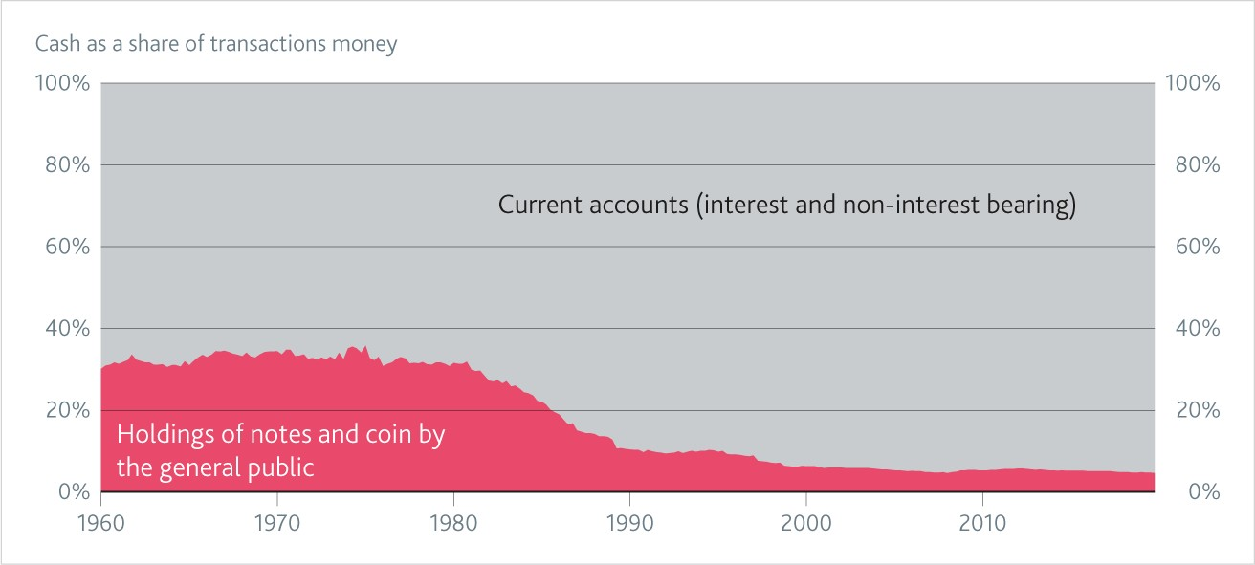

Source: Bank of England, and Thomas, R and Dimsdale, N (2017) "A Millennium of UK Macroeconomic Data", Bank of England OBRA dataset: https[://www.bankofengland.co.uk/-/media/boe/files/statistics/research-datasets/a-millennium-of-macroeconomic-data-for-the-uk.xlsx](http://www.bankofengland.co.uk/-/media/boe/files/statistics/research-datasets/a-millennium-of-macroeconomic-data-for-the-uk.xlsx) Total transactions money is defined as the sum of notes and coin held by the non-bank general public (total notes and coin excluding holdings by the banking system) plus interest and non-interest bearing current accounts. This was previously known as the aggregate M1. Prior to 1989Q2 the data only cover the current accounts of banks. There are then a series of breaks in the series reflecting the inclusion of building society sight deposits into the data: for example, in 1989Q2 and 1997Q2 following the conversion of the Abbey National and Halifax building societies into banks (the major high street banks also introduced interest-bearing sight deposits in 1989); a further break occurs in 1998Q4 when building society instant access accounts are included in the total for the first time. As building societies only introduced current accounts in the 1980s this does not affect the comparison between 1960 and today mentioned in the text but the chart is likely to overstate the share of cash somewhat in the 1980s.

# Chart 2: Payment volumes by payment method

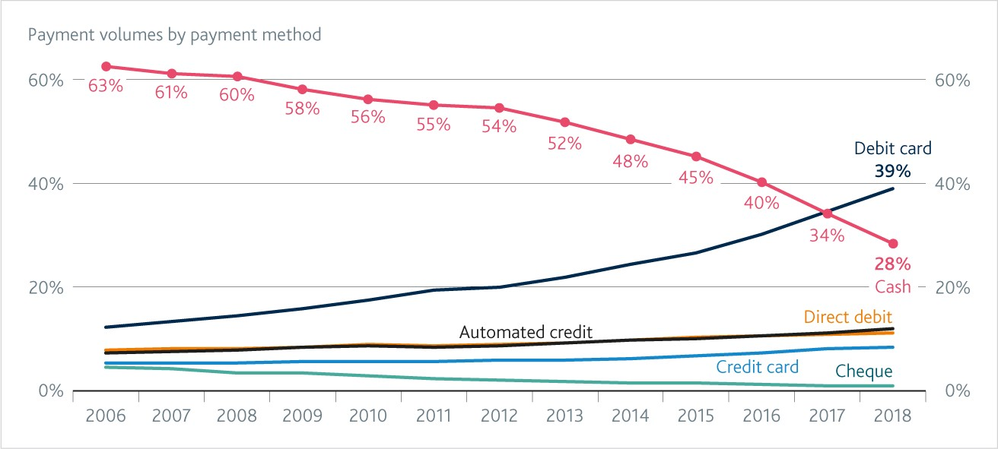

Source: *Payments Market Summary Report 2019, UK Finance*